NIFTY 50 · INTRADAY · 5-MINUTE CHART
Opening Range Breakout (9:20 ORB)
Complete Rulebook: Setups, Filters, Examples and Trade Rules, Long & Short
One trade decision per day, made at 9:20 AM when the first 5-minute candle closes. A trade is taken only when four things agree: the 200 EMA direction, a previous-day level break, the first-candle quality, and the gap filter. If any one fails, there is no trade that day.
9:20  Decision time (AM) | 30  Stop-loss (points) | 60  Target (points) | 1 : 2  Risk-reward

1. Strategy Overview
This is a single-entry ORB. The strategy looks at exactly one candle (9:15 to 9:20) and decides once. It never enters at 9:25, 9:30 or any later time, and it never re-enters after a stop-loss or a target.
Item | Rule
Instrument | Nifty 50 spot index
Chart timeframe | 5 minutes
Signal candle | First candle of the day, 9:15 to 9:20 AM
Decision and entry time | 9:20 AM only, after that candle has closed
Directions | BUY and SELL
Trend filter | 200 EMA (never trade against it)
Level filter | Break of at least one previous-day resistance (BUY) or support (SELL), major or inner
Candle filter | Candle colour matches the direction, at least one candle pattern matches (hammer, engulfing or full-body for BUY; shooting star, engulfing or full-body for SELL), and the wick on the wrong side is at most 20% of the candle range
Stop-loss / Target | 30 points / 60 points (1 : 2)
Maximum trades per day | 1
Gap filter | No trade if the opening gap (9:15 open minus previous day close) is more than 250 or 300 points, up or down. The final value (250 or 300) is still to be chosen

Long and short at a glance
Condition | BUY (long) | SELL (short)
200 EMA | Price above 200 EMA | Price below 200 EMA
Level break | Any one previous-day resistance (major or inner) is broken upward | Any one previous-day support (major or inner) is broken downward
Candle colour | Green (close above open) | Red (close below open)
Wrong-side wick (must be 20% or less of range) | Upper wick. A long lower wick is fine. | Lower wick. A long upper wick is fine.
Stop-loss | Entry − 30 | Entry + 30
Target | Entry + 60 | Entry − 60

Core principle
A trade against the 200 EMA is never allowed. Above the EMA the strategy only plans BUYs, below it only SELLs. A level break, a good candle and a valid gap must all agree with that direction.

3. Decision Flow
Run the checks in this order. The first failed check ends the day with no trade.
- Gap filter. Gap = open of the 9:15 candle minus the previous day close. If the gap, up or down, is more than 250 or 300 points, there is no trade today.
- 200 EMA direction. If the 9:20 close is above the 200 EMA, only BUY is possible. If it is below the 200 EMA, only SELL is possible.
- Previous-day level. For BUY, the 9:20 close must be above at least one previous-day resistance (major or inner). For SELL, it must be below at least one previous-day support (major or inner).
- Candle colour and pattern. Green candle for BUY, red candle for SELL, and at least one candle pattern must match (hammer, engulfing or full-body for BUY; shooting star, engulfing or full-body for SELL).
- Wick rule. For BUY, the upper wick must be 20% or less of the whole candle range (a long lower wick is fine). For SELL, the lower wick must be 20% or less of the whole candle range (a long upper wick is fine).
- Enter at 9:20. BUY: stop-loss 30 points below entry, target 60 points above entry. SELL: stop-loss 30 points above entry, target 60 points below entry. If any of the six steps fails, there is no trade today.

4. Filter 1: The 200 EMA
Price position at 9:20 | Allowed | Rejected
Above 200 EMA | BUY | SELL
Below 200 EMA | SELL | BUY

- Use the 200-period EMA on the 5-minute Nifty 50 spot chart.
- Compare the close of the 9:20 candle with the EMA value on that same candle (TO CONFIRM).
- A fresh cross of the EMA is allowed. If the market was below the EMA earlier and the 9:15 candle closes above it, BUY is allowed if every other rule passes. The same applies in reverse.
- If the close is exactly on the EMA, no trade.

5. Filter 2: Previous-Day Support and Resistance
The previous trading day has levels drawn as purple zones on the charts. There are two kinds:
 | Major level | Inner level
Where | Top of the previous day (resistance) or bottom (support) | A smaller level inside the previous day, below the major resistance or above the major support
Example chart | Upper purple zone (Example 1) | Lower purple zone (Example 1)
Counts for a trade? | Yes, if broken | Yes, if broken

Key rule: breaking any one level is enough
It is not necessary to break the major level. If the major previous-day resistance is still unbroken at 9:20 but a smaller inner resistance is broken, the BUY is valid. The same holds for SELL with supports. Many levels can be marked on the chart. One break is enough.

- BUY: at least one previous-day resistance (major or inner) is broken upward.
- SELL: at least one previous-day support (major or inner) is broken downward.
- Definition of a break: the 9:20 candle must close beyond the level. A wick poking through the level does not count (TO CONFIRM; this follows your earlier reference rulebook).
- For a zone (a band with a top and bottom edge), a BUY break means the close is above the top edge, and a SELL break means the close is below the bottom edge (TO CONFIRM).
- How levels are found (swing highs and lows of the previous day, or levels you draw by hand) is not yet defined and must be decided before the rules can be tested.

Example 1: BUY, inner resistance broken (16 Sep 2025)
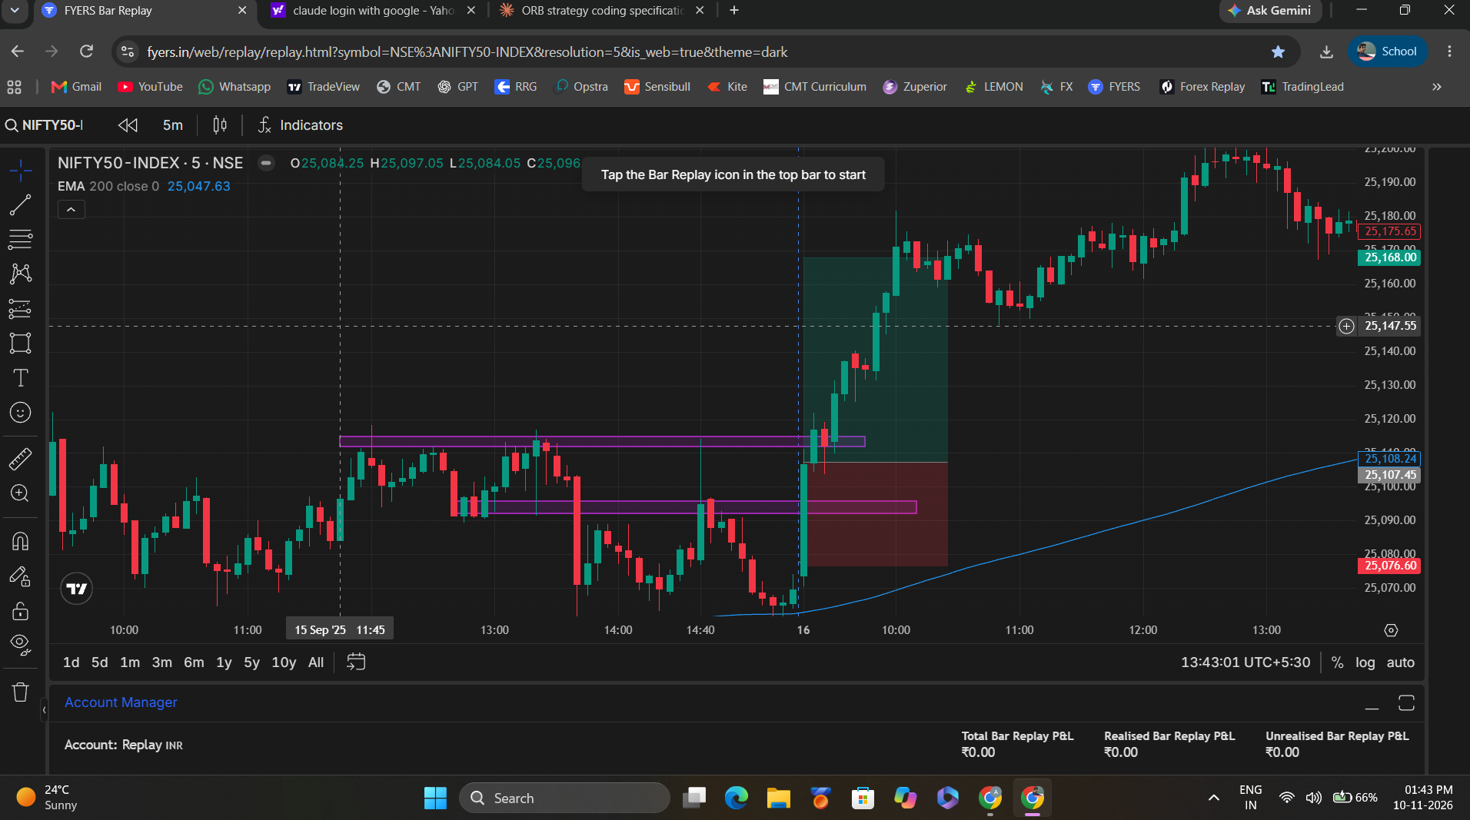
Example 1. The first candle on 16 Sep breaks the lower purple zone (inner resistance). The upper zone (major) is still above the close.
- Price is above the 200 EMA (EMA about 25,050), so BUY is allowed.
- The big green candle closes above the lower purple zone, which is an inner resistance of the previous day.
- The upper purple zone (major resistance) is not yet broken at 9:20, and the trade is still valid because one previous-day level was broken.
- The candle is a strong green body with a small upper wick (about 11% of the candle), which is under the 20% maximum for a BUY.
- Entry about 25,107, stop-loss about 25,077 (−30), target about 25,168 (+60).

6. Filter 3: Candle Quality and the 20% Wick Rule
The 9:15 to 9:20 candle must be a strong candle in the trade direction, and it must not have a big wick on the wrong side. For a BUY, the wrong side is the top of the candle (price went up and was pushed back down). For a SELL, the wrong side is the bottom of the candle (price went down and was pushed back up). A long wick on the other side is good, because it shows the move in your direction being defended.
 | BUY | SELL
Candle colour | Green: close > open | Red: close < open
Wick that is allowed to be long (good) | Lower wick (price dipped, then buyers pushed it back up) | Upper wick (price spiked up, then sellers pushed it back down)
Wick that must be small (bad) | Upper wick | Lower wick
Formula for the bad wick | (H − max(O,C)) ÷ (H − L) | (min(O,C) − L) ÷ (H − L)
Pass if | Upper wick is 20% or less of the whole candle range | Lower wick is 20% or less of the whole candle range
Fail | Upper wick is more than 20%: no trade today | Lower wick is more than 20%: no trade today

- The percentage is of the whole candle range (high minus low), not of the body.
- A BUY candle that is half upper wick and half body is rejected. A SELL candle that is half lower wick and half body is rejected.
- Keep the 20% wick limit as an adjustable setting (MAX_BAD_WICK_PCT = 20) so it can be changed to 25 if needed.
Worked calculation. BUY candle: open 25,130, high 25,140, low 25,096, close 25,136. Range = 140 − 96 = 44 points. Upper wick = 25,140 − 25,136 = 4 points = 9% of the range, which is 20% or less, so it passes (the long lower wick is fine, this is a hammer-type candle). A different BUY candle with open 25,102, close 25,120, high 25,140 and low 25,100 has a range of 40 and an upper wick of 20 points = 50%, which is more than 20%, so it is rejected.
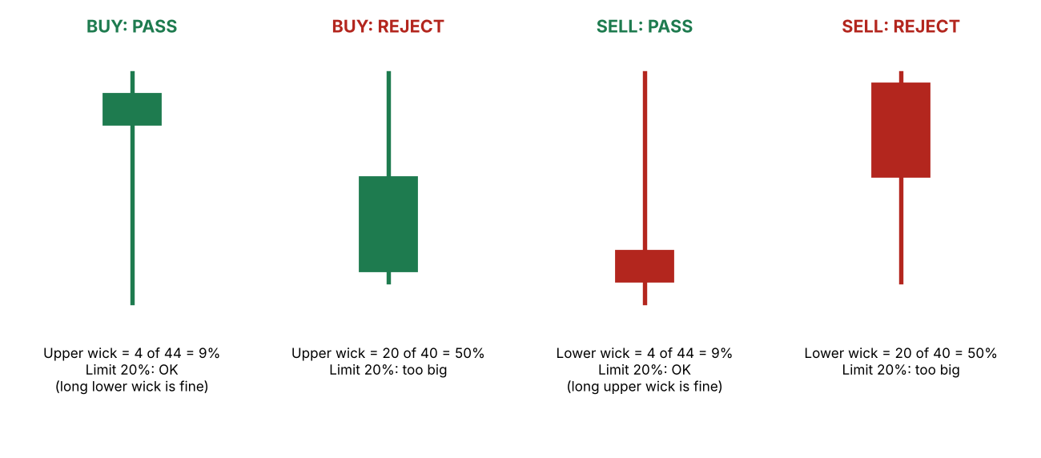
The 20% wick rule: BUY, the upper wick must be 20% or less of the candle range. SELL, the lower wick must be 20% or less.

Candle patterns (at least one must match)
 | BUY | SELL
A. Pin bar | Hammer: small body near the top, long lower wick | Shooting star: small body near the bottom, long upper wick
B. Engulfing | Green candle whose body engulfs the previous candle body | Red candle whose body engulfs the previous candle body
C. Full-body candle | Green, total wick (upper + lower) 20% or less of the range | Red, total wick (upper + lower) 20% or less of the range

- Only one pattern has to match. The 20% wrong-side wick rule must also pass, and a hammer or shooting star is allowed because its long wick is on the good side.
- The exact hammer and shooting-star proportions, and which candle counts as the "previous" candle for engulfing on the first candle of the day, are still to be defined.

Example 2: BUY chart (17 Sep 2025)
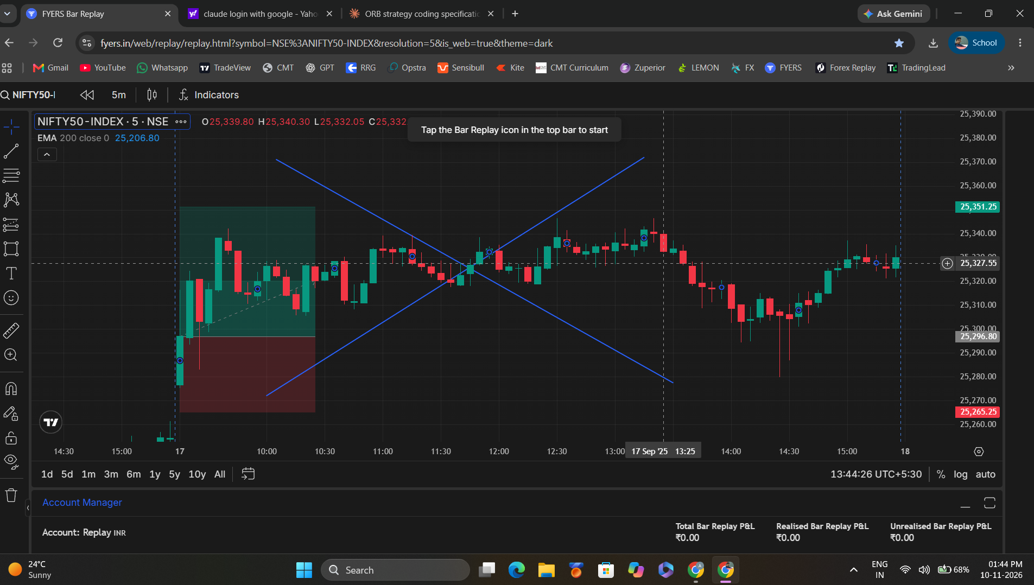
Example 2. Green opening candle, price well above the 200 EMA (about 25,207). Entry about 25,297, stop-loss about 25,265, target above.
- Price is above the 200 EMA, and the candle is green, so BUY is the allowed direction.
- Measured from the screenshot, the upper wick is about 47% of the candle range and the lower wick about 3%.
- The upper wick is the wrong side for a BUY. By the 20% rule written here this candle fails. TO CONFIRM.
- No previous-day level is drawn on this screenshot.

Example 3: SELL chart (24 Sep 2025)
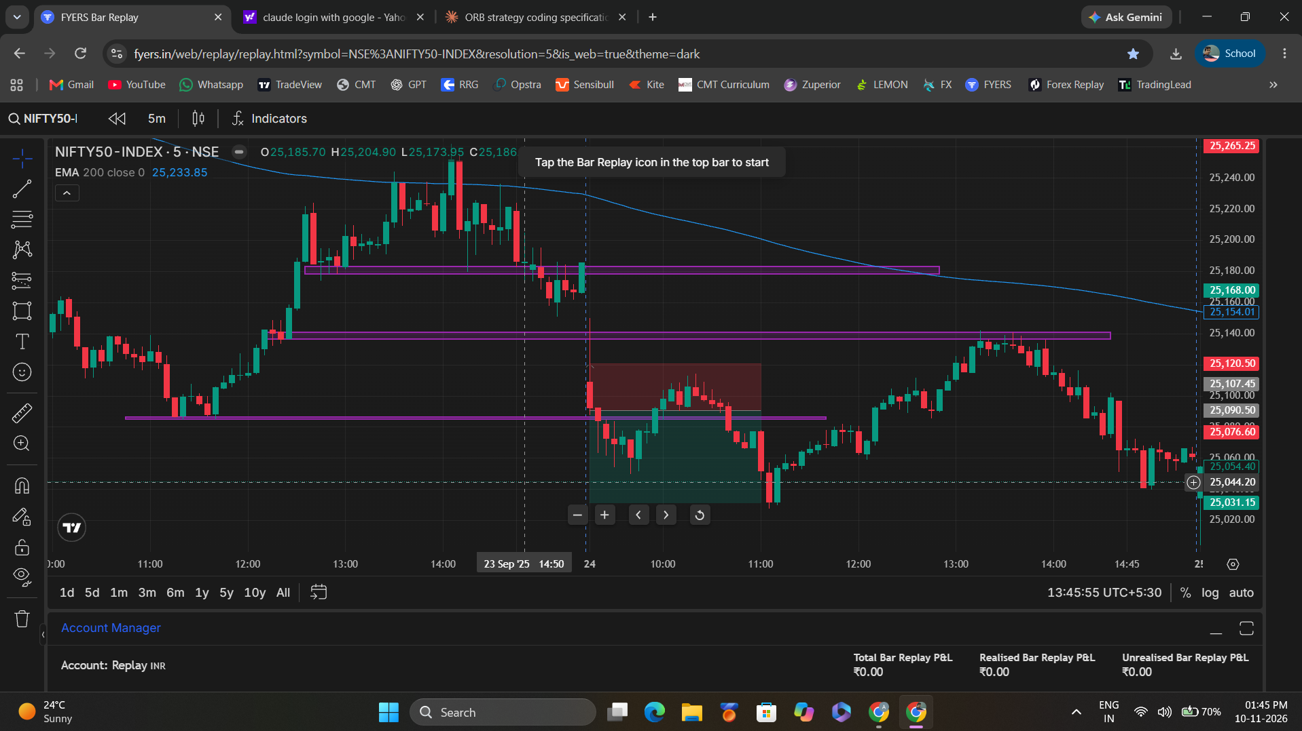
Example 3. A red opening candle with a very long upper wick, price below the 200 EMA (about 25,234).
- Price is below the 200 EMA and the candle breaks a previous-day support, so direction and level checks pass.
- Measured from the screenshot: upper wick about 66% of the candle range, body about 27%, lower wick about 7%.
- For a SELL the lower wick is the wrong side. At about 7% it is under 20%, so by the 20% rule written here this candle passes the wick check.
Examples 2 and 3 do not match the written wick rule
You described Example 3 as a trade that must not be taken because of its wick, but its big wick is on the upper side, which the rule treats as good for a SELL. Example 2 has a big upper wick, which the rule treats as bad for a BUY. Either the two examples or the rule needs correcting. Until this is confirmed, the rule as written (BUY: upper wick 20% or less; SELL: lower wick 20% or less) is what applies.

7. Gap Filter
- Gap = open of the 9:15 candle minus the previous day close. A positive number is a gap up and a negative number is a gap down.
- If the gap, up or down, is more than 250 or 300 points, there is no trade that day. This applies to both BUY and SELL.
- The maximum gap is 250 or 300 points (final value to be confirmed). Keep it as an adjustable setting (MAX_GAP_POINTS).
- Worked example: previous close 25,000 and 9:15 open 25,280 gives a gap of +280 points. With a 250-point limit the trade is rejected. With a 300-point limit the gap is allowed and the other checks continue.

8. Entry, Stop-Loss and Target
Parameter | BUY | SELL
Entry time | 9:20 AM, after the first candle closes | 9:20 AM, after the first candle closes
Entry price (E) | Close of the 9:15 candle (TO CONFIRM) | Close of the 9:15 candle (TO CONFIRM)
Stop-loss | E − 30 | E + 30
Target | E + 60 | E − 60
Risk-reward | 1 : 2 | 1 : 2

- Distances are in index points, not rupees. Rupee risk depends on quantity (for example 30 points × 75 quantity = ₹2,250).
- One trade per day. After the stop-loss or the target is hit, the strategy is done for the day.
- If the stop-loss and the target are both touched in the same 5-minute candle, which came first is unknown from the candle alone (TO CONFIRM; conservative default: count the stop-loss first).
- If neither is hit, close the position at the end of the session (time to be confirmed, for example 3:15 PM).

9. Reasons a Trade Is Rejected
Check | Rejected when
Gap | Opening gap (9:15 open minus previous close), up or down, is more than 250 or 300 points
Timing | Any attempt to enter before 9:20 AM or after 9:20 AM (for example at 9:25 or 9:30). The only entry time is 9:20 AM
200 EMA | BUY below the EMA, SELL above the EMA, or close exactly on the EMA
Level | The 9:20 close has not broken any previous-day resistance (BUY) or any previous-day support (SELL), major or inner
Colour | BUY candle is red or SELL candle is green
Pattern | None of the patterns matches: hammer, engulfing or full-body for BUY; shooting star, engulfing or full-body for SELL
Wick | BUY: upper wick is more than 20% of the candle range. SELL: lower wick is more than 20% of the candle range
Candle | Zero-range candle (high equals low)

10. Rule Matrix
Rule | BUY | SELL
Decision time | 9:20 AM | 9:20 AM
Direction filter | Close above 200 EMA | Close below 200 EMA
Level break | Any 1 previous-day resistance (major or inner) | Any 1 previous-day support (major or inner)
Candle | Green, a pattern matches, upper wick ≤ 20% of range | Red, a pattern matches, lower wick ≤ 20% of range
Gap | Opening gap of 250 or 300 points or less | Opening gap of 250 or 300 points or less
Stop-loss / Target | E − 30 / E + 60 | E + 30 / E − 60
Trades per day | 1 | 1

